**Web Development (Introduction) WEDE5020**

**ST10104699**

**Denzel Kgopotso Seanego**

**Table of Content**

Organization Overview...........................................................................................Page 3

Website Objective and goals..................................................................................Page 3

Current Website analysis.......................................................................................Page 4

Proposed website features and functionality...........................................................Page 4

Proposed website features and functionality...........................................................Page 5

Technical requirements..........................................................................................Page 6

Timeline and milestones........................................................................................ Page 6

Budget...................................................................................................................Page 7

Reference list.........................................................................................................Page 8

1. Organization Overview

- DK bookstore

- DK bookstore was first established in 2005 with only one physical store in Polokwane, Limpopo with the main goal of selling school textbooks at a cheap price for students who could not afford it at school.

-Our vision is to create and foster a love of reading for many people and assist schools with the distribution of necessary textbooks.

-Our target market is people who love to read, School in need of physical textbooks

2. Website Objective and goals

- The specific goal of the website is to sell different types of books to people willing to read and sell textbooks to schools and students.

- According to Qlik (2025) “KPI stands for key performance indicator, a quantifiable measure of performance over time for a specific objective.”

- **Operational** - “These KPIs typically measure performance in a shorter time frame and are focused on organizational processes and efficiencies.” (Qlik, 2025)

3. Current Website analysis

Strengths

- Simple UI design

- Easy to navigate the website

-Website gives all the necessary

Weakness

- Lack of content

- Lack of details

-Lack of content: Can be fixed by adding new features during development so the website can offer more things to interact with.

-Lack of details: Can be addressed using different stylings for each tab so the website may feel more alive.

4. Proposed website features and functionality

**Homepage**

-Show the basic purpose of the website and shortcut to other tabs making navigation easier.

**Books**

-Displaying all the books available prices and names of all the books.

**Contact us**

-Display all the necessary contact information for people to us to contact the store.

**About us**

-Give a history of the business and their future intentions.

5. Design and user experience

**Color scheme**

-The websites primary color scheme will mainly focus on white and blue

**Typography**

-Using a font that is presentable and not too straining on the eyes

**Layout and design**

-A simple layout and design that makes navigation through the website easier for users.

**User experience consideration**

-All functions must think of the users experience first and foremost and so that they are not too overwhelmed by the website's appearance.

Homepage

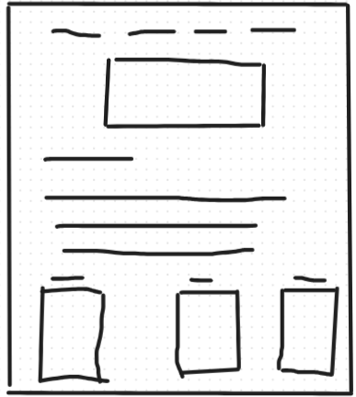

6. Technical requirements

-HTML will be used for the basic development of the website such as the adding of the different tabs for the website, the texts and the logos and the different books available and CSS will be used for the details and extra features for the website like adding different colors to make other aspects shine.

Hosting

- “Web hosting -- also known as *website hosting* or *webhosting* -- is the process where a web hosting provider stores and maintains website files and applications on a server to make its customers' websites accessible on the internet.” (Yasar, 2025)

Domain name

- “A domain name can be purchased before developing a website, but a website can't go online without a domain name.” (Yasar, 2025)

7. Timeline and milestones

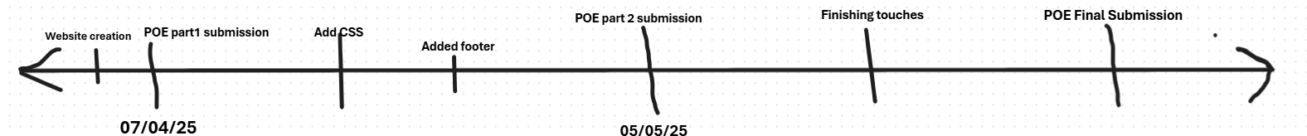

8. Budget

**Development**

-R 8,000

**Hosting**

-R 2,000 per month

**Maintenance**

-R5,000 per month

Reference list:

McKinnon, J. 2025. *How to Make a website: Step-By-Step Guide for Beginners (2025). [blog] 30* January

Available at:

[How to Make a Website: Step-by-Step Guide](https://websitesetup.org/)

[Accessed on: 05 April 2025]

Qlik, 2025. *What is KPS*. [Online]

Available at:

<https://www.qlik.com/us/kpi#:~:text=KPI%20stands%20for%20key%20performance,the%20organization%20make%20better%20decisions>.

[Accessed on: 5 April 2025]

Yasar, K. 2025. hosting *(website hosting, web hosting and webhosting). [blog] 5 April.*

Available at:

<https://www.techtarget.com/whatis/definition/hosting-Web-site-hosting-Web-hosting-and-Webhosting>

[Accessed on: 05 April 2025]